1. The Exponential Distribution (ctd)
Just be clear, in the last lecture we gave two formulas – one for the probability distribution of an exponential process, and one for the cumulative distribution function. These formulas look similar, so let's review them and how they differ in application.

The probability density function for the length of time between events in an exponential process is:

Pr(X = x) = f(X) = λe^{– λx}

Note that this is denoted by a lower-case f(x), which is our convention for a probability distribution. This gives the probability density at a single value of X = x, e.g. the ordinate value below where x = 5:

The cumulative distribution function for an exponential process is:

Pr(X ≤ x) = F(x) = 1 – e ^{–λx}

Note how we denote this with a capital F(x). As a cumulative function, this calculates the area under the probability distribution less than or equal to x (e.g., the white-shaded region in the plot above).

Homework

Read pp. 209–210. Prob. 5.34.

2. Sampling Theory and the Central Limit Theorem
Goal

Our goal in this section is to understand and relate to each other three concepts:

- sampling distribution of the mean
- Central Limit Theorem
- Standard error of the mean

As we shall see, all three of these are integrally connected.

Motivation

Most of the statistical inferences we will be making from this point forward will involve the principles covered here, so it is important we understand them.

Definitions

Sample. A set of objects or measurements drawn at random from a larger population

Population: {1, 2, 3, 4, 5, 6, 7, 8, 9, 10}
Sample: {1 4 7 }

Sampling. The repeated drawing of random samples of size n from a population. Here n = 3.

Population: { 1, 2, 3, 4, 5, 6, 7, 8, 9, 10 }
Sample 1: { 1 4 7 }
Sample 2: { 2 5 8 }
Sample 3: { 7 9 10 }
etc. …

Probability distribution of the sample mean. Every sample has a mean. The sample mean () changes from sample to sample:

Population: { 1, 2, 3, 4, 5, 6, 7, 8, 9, 10 }
Sample 1: { 1 4 7 } = 4
Sample 2: { 2 5 8 } = 5
Sample 3: { 7 9 10 } = 8.67
etc. …

The sampling distribution of the mean is the probability distribution of sample means of size n drawn from the same population.

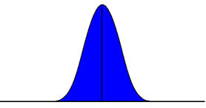
Probability Distribution of Sample Means

Central Limit Theorem

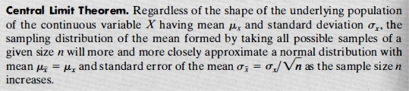

The central limit theorem says, that as sample size (n) becomes large, the sampling distribution will approximate a normal distribution, regardless of the shape of the original distribution. In the example below, the population distribution is very irregular (black curve). However the sampling distribution (distribution of sample means draw from the population) starts to approximate a normal distribution, even with n = 5.

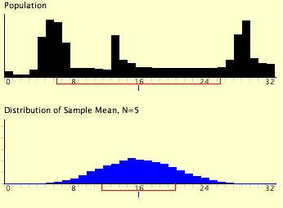

As sample size n increases, the sampling distribution of the mean will not only get close to the form of a normal distribution, it's variance will get smaller.

Sampling Distributions of the Mean for n = 2, n = 4, n = 8

3. The Standard Error of the Mean

As a probability distribution, the sampling distribution of sample means itself has a mean (expected value) and a standard deviation.

Mean of the Sampling Distribution of Sample Means

Not surprisingly, the mean of the distribution of sample means is the same as the population mean.

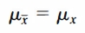

Standard Error of Sample Means

The standard deviation of a sampling distribution is also called the standard error. There is a very simple formula to estimate the standard error of sample means:

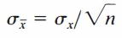

where n is the size of each sample. This value is known as the standard error of the mean. The variance of the sample mean is obtained by squaring the formula above.

Note how, per our simulation results, the standard error decreases as n increases. As n approaches infinity, the standard error approaches 0. This makes sense, because extremely large samples will all vary little from the population mean.

Once again, the standard error of the mean is the same as the standard deviation of the sampling distribution of sample means.

Video
https://www.khanacademy.org/math/probability/statistics-inferential/sampling_distribution/v/standard-error-of-the-mean

Demonstration
http://onlinestatbook.com/stat_sim/sampling_dist/

Read pp. 218–219.

